अखिलभारतीयआयुर्विज्ञानसंस्थान, मंगलगिरी
ALL INDIA INSTITUTE OF MEDICAL SCIENCES
Mangalagiri, Guntur (A.P.) – 522503
Website:www.aiimsmangalagiri.edu.in

Ref. No.: AIIMS MG/STORE/Tender/2020-21/Anaesthesiology/PAC/Ambu Mark IV Resuscitator
Dated: 03/12/2020
Subject: Proposal for the procurement of “AMBU Mark IV Resuscitator (Adult)” for the Anaesthesiology department, AIIMS Mangalagiri.
The request received from Anaesthesiology Department, AIIMS Mangalagiri for the purchase of captioned Item from M/s AMBU A/S, Baltorpbakken 13, DK-2750 Ballerup, Denmark, on Proprietary basis.
The Notice is being uploaded for general information of Aspirant Manufacturers/Dealers/ Distributors to submit their objections/proposal, if any, on proprietorship of these items.
In case, the product of any Manufacturer/Authorized distributor/dealer conforms to the enclosed specifications, they may submit their proposal for the supply same item along with the following:
- Product brochure;
- Point-by-point compliance of the, Enclosed specifications, along with all Relevant documentary evidence.
The objection/ proposal should be sent in sealed cover to, the office of Sr. Store Officer, 1st floor Dharmsala building, Old TB Sanatorium Road, AIIMS Mangalagiri, Mangalagiri, Guntur (AP), 522503; so as to reach on or before 17/12 /2020 upto15:00 Hrs., failing which it will be presumed that no any other vendor is interested to offer comments/protest and case will be decided accordingly on its merit.
The reference number: ………………, Date: …/../2020, due on: …/../2020 should be super scribed on sealed envelope.

Yours faithfully

Sr. Store officer
(for DIRECTOR AIIMS Mangalagiri)

Encl: 1. PAC Certificate
2. Schedule of requirement/ Technical Specification

PAC CERTIFICATE
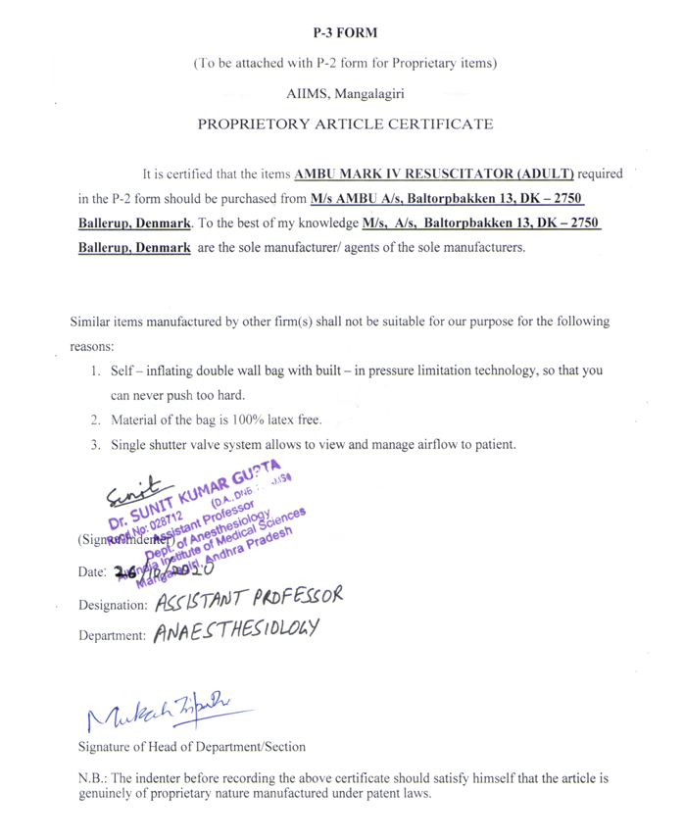
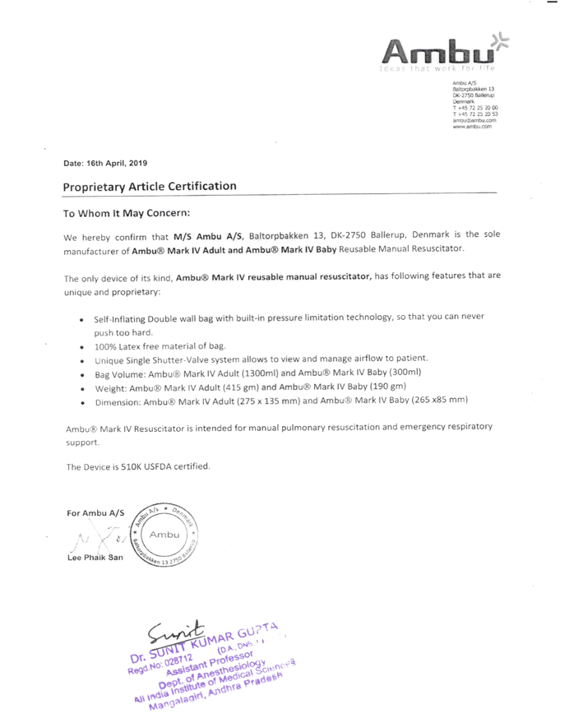

TECHNICAL SPECIFICATION FOR AMBU MARK IV RESUSCITATOR (ADULT
