अखिल भारतीय आयुर्विज्ञानसंस्थान, मंगलगिरी
ALL INDIA INSTITUTE OF MEDICAL SCIENCES
Mangalagiri, Guntur (A.P.) – 522503
Website: www.aiimsmangalagiri.edu.in

Ref. No.: AIIMS MG/STORE/Tender/2020-21/Pathology/PAC/Trinocular Upright Microscope
Dated: 03/12/2020
Subject: Proposal for the procurement of “TRINOCULAR UPRIGHT MICROSCOPE” for the Pathology department, AIIMS Mangalagiri.
The request received from Pathology Department, AIIMS Mangalagiri for the purchase of captioned Item from OLYMPUS CORPORATION, Shinjuku monolith, 3-1 Nishi- Shinjuku 2-chrome, Shinjuku-ku, Tokyo 163-0914, Japan on Proprietary basis.
The Notice is being uploaded for general information of Aspirant Manufacturers/Dealers/ Distributors to submit their objections/proposal, if any, on proprietorship of these items.
In case, the product of any Manufacturer/Authorized distributor/dealer conforms to the enclosed specifications, they may submit their proposal for the supply same item along with the following:
- Product brochure;
- Point-by-point compliance of the, Enclosed specifications, along with all Relevant documentary evidence.
The objection/ proposal should be sent in sealed cover to, the office of Sr. Store Officer, 1st floor Dharmsala building, Old TB Sanatorium Road, AIIMS Mangalagiri, Mangalagiri, Guntur (AP), 522503; so as to reach on or before 17/12/2020 upto15:00 Hrs., failing which it will be presumed that no any other vendor is interested to offer comments/protest and case will be decided accordingly on its merit.
The reference number: ………………, Date: …/../2020, due on: …/../2020 should be super scribed on sealed envelope.

Yours faithfully
Sr. Store officer
(for DIRECTOR AIIMS Mangalagiri)

Encl: 1. PAC Certificate
2. Schedule of requirement/ Technical Specification
PAC CERTIFICATE
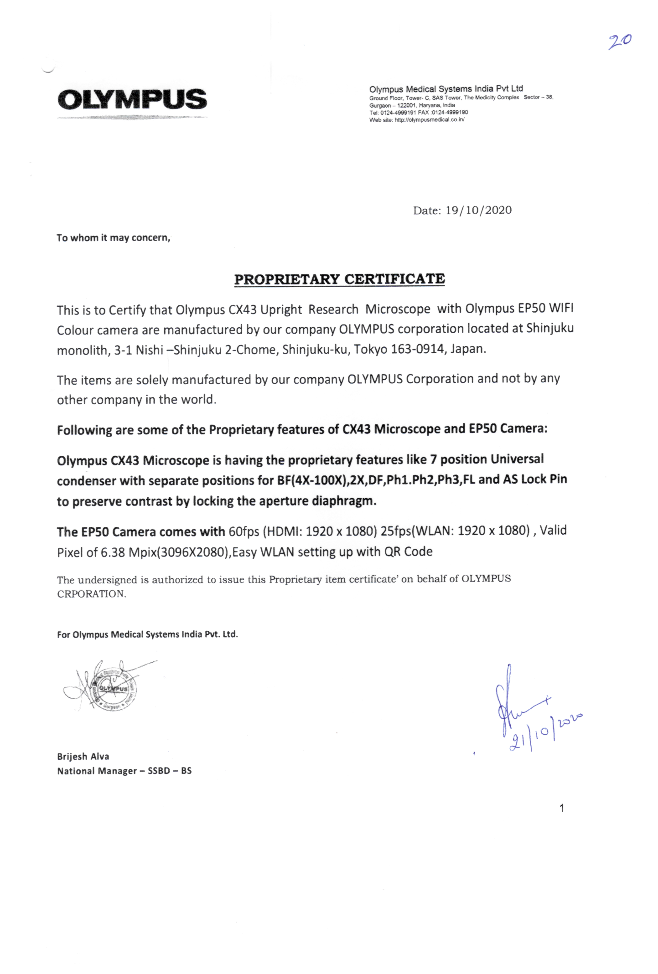
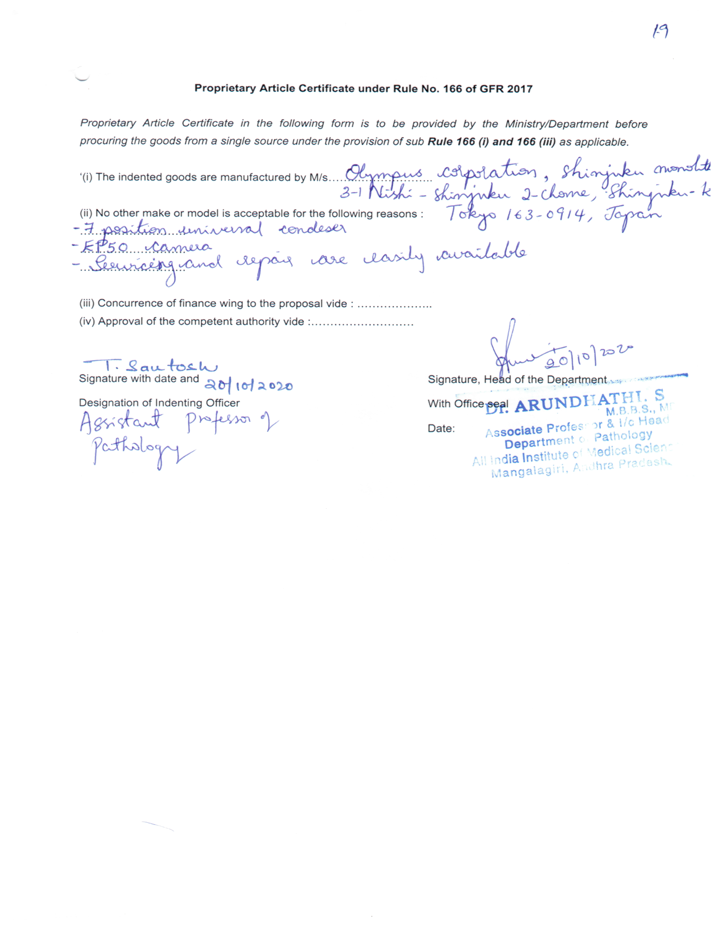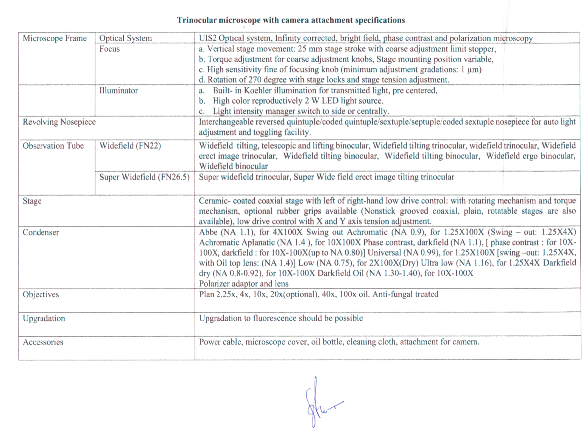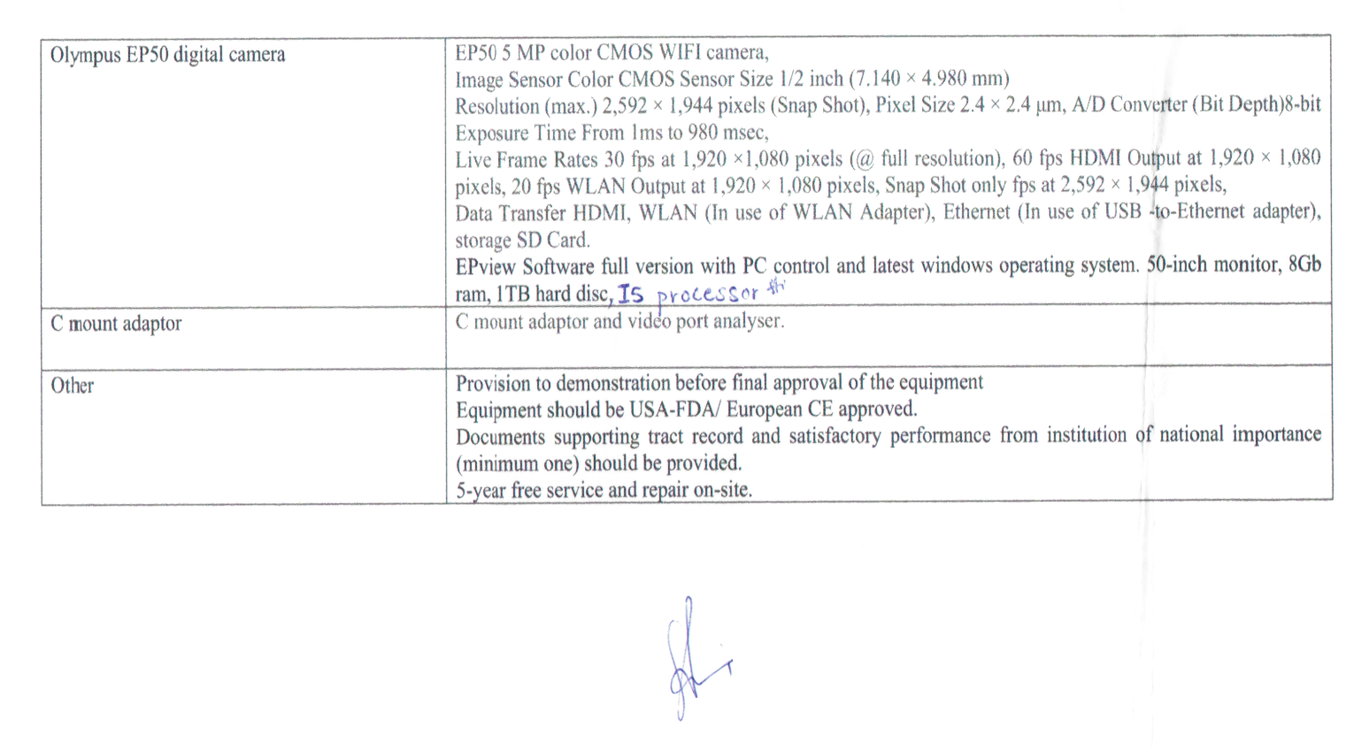
TRINOCULAR MICROSCOPE WITH CAMERA ATTACHMENT SPECIFICATIONS
Microscope Frame | Optical System | UIS2 Optical system, Infinity corrected, bright field, phase contrast and polarization microscopy
 | Focus | - Vertical stage movement: 25 mm stage stroke with coarse adjustment limit stopper,  - Torque adjustment for coarse adjustment knobs, Stage mounting position variable,  - High sensitivity fine of focusing knob (minimum adjustment gradations: I pm)  - Rotation of 270 degree with stage locks and stage tension adjustment.
 | Illuminator | - Built- in Koehler illumination for transmitted light, pre centered,  - High color reproductively 2 W LED light source.  - Light intensity manager switch to side or centrally.
Revolving Nosepiece |  | Interchangeable reversed quintuple/coded quintuple/sextuple/septuple/coded sextuple nosepiece for auto light adjustment and toggling facility.
Observation Tube | Widefield (FN22) | Widefield tilting, telescopic and lifting binocular, Widefield tilting trinocular, widefield trinocular, Widefield erect image trinocular, Widefield tilting binocular, Widefield tilting binocular, Widefield ergo binocular, Widefield binocular
 | Super Widefield (FN 26.5) | Super widefield trinocular, Super Wide field erect image tilting trinocular
Stage |  | Ceramic- coated coaxial stage with left of right-hand low drive control: with rotating mechanism and torque mechanism, optional rubber grips available ( Non-stick grooved coaxial, plain, rotatable stages are also available), low drive control with X and Y axis tension adjustment.
Condenser |  | Abbe ( NA 1.1), for 4X100X Swing out Achromatic ( NA 0.9), for 1.25X100X (Swing - out: 1.25X4X) Achromatic Aplanatic ( NA 1.4 ), for 10X100X Phase contrast, darkfield (NA 1.1), [ phase contrast : for 10X- 100X, darkfield : for 10X-100X( up to NA 0.80)] Universal ( NA 0.99), for 1.25X 100X [swing -out: 1.25X4X, with Oil top lens: ( NA 1.4)] Low ( NA 0.75), for 2X100X( Dry) Ultra low ( NA 1.16), for 1.25X4X Darkfield dry ( NA 0.8-0.92), for 10X-100X Darkfield Oil ( NA 1.30-1.40), for 10X-100X  Polarizer adaptor and lens
Objectives |  | Plan 2.25x, 4x, 10x, 20x(optional), 40x, 100x oil. Anti-fungal treated
Upgradation |  | Upgradation to fluorescence should be possible
Accessories |  | Power cable, microscope cover, oil bottle, cleaning cloth, attachment for camera.
Olympus EP50 digital camera |  | EP5G 5 MP color CMOS WIFI camera,  Image Sensor Color CMOS Sensor Size 1/2 inch (7.140 x 4.980 mm)  Resolution (max.) 2592 * 1944 pixels (Snap Shot), Pixel Size 2.4 x 2.4 pm, AD Converter (Bit Depth) 8 bit  Exposure Time From 1 ms to 980 msec,  Live Frame Rates 30 fps at 1920 x 1080 pixels (@ full resolution), 60 fps HDMI Output at 1,920 * 1,080  pixels, 20 fps WLAN Output at 1920 x 1080 pixels, Snap Shot only fps at 2,592 x 1944 pixels,  Data Transfer HDMI, WLAN (In use of WLAN Adapter), Ethernet (In use of USB -to-Ethernet adapter),  storage SD Card.  EPview Software full version with PC control and latest windows operating system. 50-inch monitor, 8Gb ram, 1TB hard disc, I5 processor.
C mount adaptor |  | C mount adaptor and video port analyser.
Other |  | Provision to demonstration before final approval of the equipment  Equipment should be USA-FDA/ European CE approved.  Documents supporting tract record and satisfactory performance from institution of national importance (minimum one) should be provided.  5-year free service and repair on-site.

