अखिलभारतीयआयुर्विज्ञानसंस्थान, मंगलगिरी
ALL INDIA INSTITUTE OF MEDICAL SCIENCES
Mangalagiri, Guntur (A.P.) – 522503
Website:www.aiimsmangalagiri.edu.in

Ref. No.: AIIMS MG/STORE/Tender/2020-21/Anaesthesiology/PAC/ video laryngoscope with d- blade
Dated: 03/12/2020
Subject: Proposal for the procurement of “VIDEO LARYNGOSCOPE WITH D- BLADE” for the Anaesthesiology department, AIIMS Mangalagiri.
The request received from Anaesthesiology Department, AIIMS Mangalagiri for the purchase of captioned Item from M/s KARL STORZ Gmbh & Co. KG, Mittelstrasse 8, D-78532 Tuttlingen, Germany, on Proprietary basis.
The Notice is being uploaded for general information of Aspirant Manufacturers/Dealers/ Distributors to submit their objections/proposal, if any, on proprietorship of these items.
In case, the product of any Manufacturer/Authorized distributor/dealer conforms to the enclosed specifications, they may submit their proposal for the supply same item along with the following:
- Product brochure;
- Point-by-point compliance of the, Enclosed specifications, along with all Relevant documentary evidence.
The objection/ proposal should be sent in sealed cover to, the office of Sr. Store Officer, 1st floor Dharmsala building, Old TB Sanatorium Road, AIIMS Mangalagiri, Mangalagiri, Guntur (AP), 522503; so as to reach on or before 17/12/2020 upto15:00 Hrs., failing which it will be presumed that no any other vendor is interested to offer comments/protest and case will be decided accordingly on its merit.
The reference number: ………………, Date: …/../2020, due on: …/../2020 should be super scribed on sealed envelope.

Yours faithfully

Sr. Store officer
(for DIRECTOR AIIMS Mangalagiri)

Encl: 1. PAC Certificate
2. Schedule of requirement/ Technical Specification

PAC CERTIFICATE

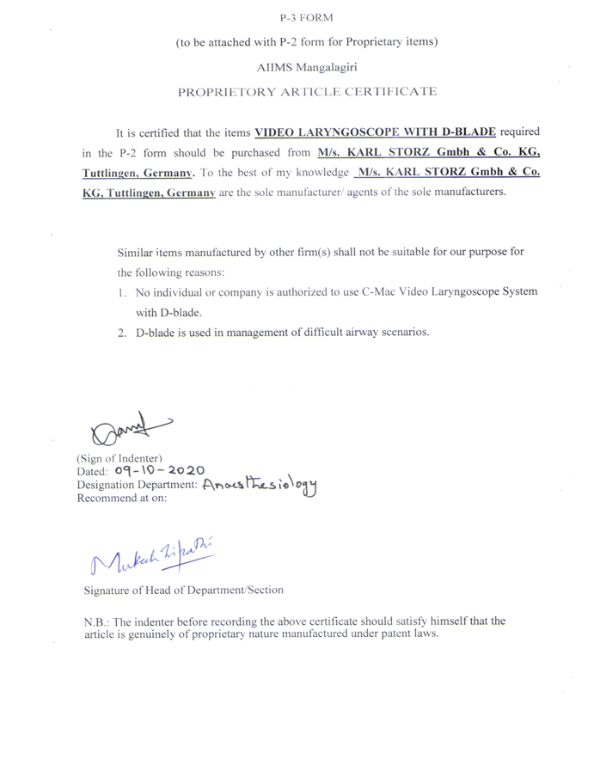
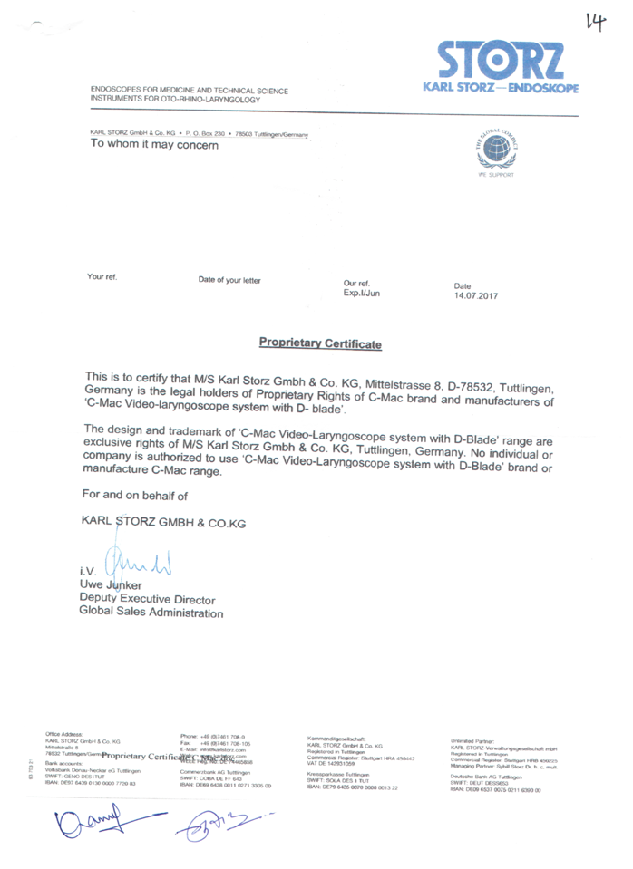

TECHNICAL SPECIFICATION FOR VIDEO - LARYNGOSCOPE D-BLADE FOR C-MAC VIDEO - LARYNGOSCOPE SYSTEM WITH D-BLADE
SPECIFICATIONS:
