अखिल भारतीय आयुर्विज्ञान संस्थान,
(स्वास्थ्य और परिवार कल्याण मंत्रालय/ प्रधानमंत्री स्वास्थ्य सुरक्षा योजना, भारत सरकार)
मंगलगिरि, आंध्रप्रदेश – 522503

All India Institute of Medical Sciences
(Ministry of Health and Family Welfare/ PMSSY, Government of India)
Mangalagiri, Andhra Pradesh – 522503

संदर्भ/Ref: AIIMS-MG/ADMIN/CEA/2020/ दिनांक/Date: 20/04/2020
परिपत्र/Circular

On implementation of recommendations of 7th Central Pay Commission, Department of Personnel & Training has issued the consolidated instructions vide OM No. A-27012/02/2017-Estt.(AL), dated 17/07/2018, for claiming Children Education Allowance (CEA) & Hostel Subsidy.

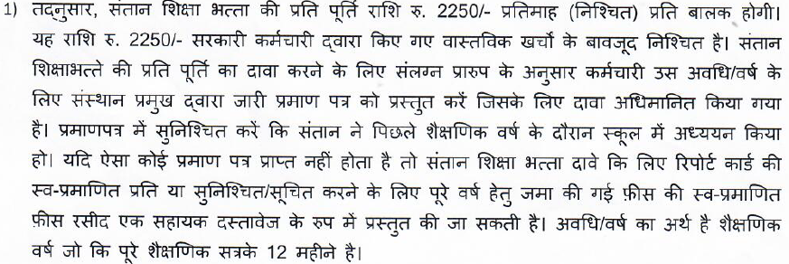

Accordingly, the amount for reimbursement of Children Education allowance will be Rs. 2250/- per month (Fixed) per child. This amount of Rs. 2250/- is fixed irrespective of the actual expenses incurred by the Govt. Servant. In order to claim reimbursement of CEA, the employee should produce a Certificate issued by the Head of the Institution for the period/year for which Claim has been preferred as per the enclosed format. The certificate should confirm that the child studied in the school during the previous academic year. In case, such certificate can’t be obtained, self- attested copy of the report card or self-attested fee receipt (s)(including e-receipt(s)} confirming/indicating that the fee deposited for the entire academic year can be produced as a supporting document to claim CEA. The period/year means academic year i.e. twelve months of complete academic session.

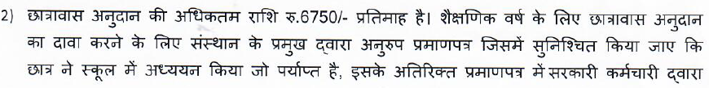

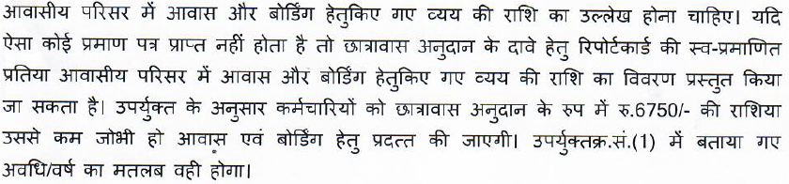

The amount of ceiling of hostel subsidy is Rs.6750/- pm. in order to claim reimbursement of Hostel subsidy for an academic year, a similar certificate from the Head of the Institution confirming that the child studied in the School will suffice, with additional requirement that the certificate should mention the amount of expenditure incurred by the Govt. Servant towards lodging and boarding in the residential complex. In case such certificate cannot be obtained, self — attested copy of the report card and original fee receipt (s)/e-receipt(s) which should indicate the amount of expenditure incurred by the Government servant towards lodging and boarding in the residential complex can be produce for claiming Hostel subsidy. The expenditure on boarding and lodging or the ceiling of Rs. 6750/ as mentioned above, whichever is lower shall be paid to the employee as Hostel Subsidy. The period/year will mean the same as explained in Sr. No. (1) above.

3)

The reimbursement of CEA and Hostel Subsidy will be done once in a financial year after completion of the financial year/academic year.

उप निदेशक (प्रशासन)
Deputy Director (Administration)

ई-मेल द्वारा सभी अधिकारी एवं कर्मचारी
All Officers and employees through e-mai1.

प्रतिलिपि/Cc : निदेशक कार्यालय/Director’s Office
नोटिसबोर्ड/ Notice Board

(CERTIFICATE TO BE ISSUED BY THE SCHOOL/INSTITUTION/COLLEGE AND TO BE SIGNED AND AUTHORISED BY THE HEAD OF THE INSTITUTION)

This is to certify that Mast./Miss

son/daughter of

is studying in this School/College/Institute in (standard)

during to (period).

His/Her Date of Birth as per our School/College/Institute records is

The School/College/Institute is recognized and affiliated to

(name of the Board) and affiliation No.

This Certificate is being issued for the purpose of claiming Children Education Allowance.

Authorized with seal & signature

(Head of the School/college/Institute)

प्रपत्र /FORM-3

संतान शिक्षा भत्ता हेतु प्रति पूर्ति
REIMBURSEMENT OF CHILDREN EDUCATION ALLOWANCE
(Ref: OM No. A-27012/02/2017-Estt. (AL), dated 17/07/2018,)

मैं प्रमाणित करता/करती हूँ कि संतान शिक्षा भत्ता दावे कि प्रति पूर्ति हेतु नीचे उल्लेखित बच्चे/बच्चा मुझ पर पूरी तरह निर्भर हैं |

I Certify that the children/child mentioned below in respect of whom reimbursement of Children Education Allowance claimed is wholly dependent upon me: -

क्र.  Sr. no. | बच्चे/बच्चों का नाम/जन्मतिथि  Name/Date of Birth of the Child/Children |  | अध्ययन के स्कूल  का नाम  School in which studying | अध्ययन की कक्षा  एवं वर्ष  Class in which  studying & A/Y |  | भुगतान किया गया  कुल स्कूल  Total Fees paid
 | नाम /Name | जन्मतिथि  DOB |  |  | Acad.  Year
1.
2.

प्रमाणित किया जाता है कि बच्चा/बच्चे पर खर्च किए जाए स्कूल का मेरे द्वारा भुगतान किया गया है |
Certified that the Fees indicated against the child/children has actually paid by me.

प्रमाणित किया जाता है कि /Certified that :-

- मेरे पति/पत्नी केंट्र सरकार कर्मचारी नहीं है / मेरे पति/पत्नी केंट्र सरकार कर्मचारी है तथा उन्होंने/वेअपने बच्चे/बच्चें के संबंध में संतान शिक्षा भत्ता हेतु दावा नहीं किया है/ करेंगे |
My spouse is not a central Government servant/ My spouse is a Central Govt. servant and that she/he has not
claimed/ will not claim children‘s educational allowance in respect of our child/children.

- उपर्युक्त विवरणों में किसी में भी बदलाव किया गया जो संतान शिक्षा भत्ता हेतु मेरी पात्रता को प्रभावित करता है, यदि ऐसा होतो मैं वचन देता/देती हूँ कि उसे शीध्रता से सूचन एवं उसका भुगतान भी वापस करुंग/करूंगी |
In the event of any change in the particulars given above which affect my eligibility for children’s educational allowance,
I undertake to intimate the same promptly and also refund payments, if any mad.

संलग्नक/Encl. :-

1.
2.
3.
4.

स्थान एवं दिनांक (सरकारी कर्मचारी के हस्ताक्षर)
PLACE & Date: (Signature of the GOVT. servant)

.......................... 2 ............................

केवल कार्यालय उपयोग हेतु / For Office use only :-

कर्मचारी द्वारा दी गई जानकारी को कार्यालय अभिलेखों से जांचा गया तथा सही पाया गया और इसलिए संतान शिक्षा भत्ता का दावा भुगतान के लिए स्वीकृत किया जाता है |

The information furnished by the employee has been verified from office records & found Correct & thus the claim of CEA is admitted for payment.

द्वारा संसाधित/Processed by.

प्रशासन कार्यालय / Administrative Officer

उप निदेशक (प्रशासन)
Deputy Director (Administration)

वित्त-सलाहकार :
Financial Advisor :

के द्वारा अनुमोदित/Approved By.
निदेशक/Director

