Curriculum Vitae
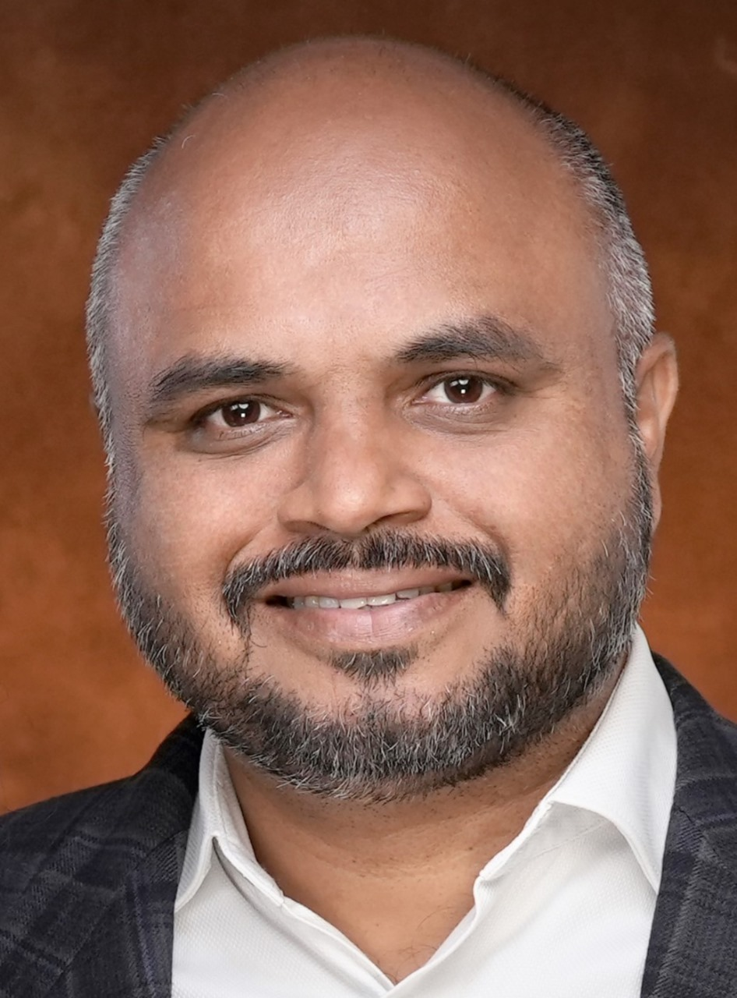

- Name : Dr. Muthuvenkatachalam S.
- Designation : Associate Professor
- Qualification : Ph.D, MHN (AIIMS)
- Specialty : Psychiatric Nursing
- Email id : muthu.venky@gmail.com
Educational qualification
Sl. No. | Degree | Year of passing | Subject | College/University
1 | D Pharm | 1999 | Pharmacy | Directorate of Medical Education, Tamil Nadu
2 | BSc | 2007 | Nursing | Rajiv Gandhi University Health Sciences, Karnataka
3 | MSc | 2010 | Psychiatry Nursing | AIIMS New Delhi
4 | PhD | 2017 | Psychiatry Nursing | INC Consortium

Research Profile:
- Orchid: https://orcid.org/0000-0002-9966-4653,
- Research gate: https://www.researchgate.net/profile/Muthuvenkatachalam-Srinivasan
- Scopus author ID: 57201870896
Area of interest: Elder mistreatment, Deaddiction, Aggression management, Patient safety, Artificial intelligence in Nursing

Membership of professional bodies:
- Life Member -Trained Nurses Association of India (TNAI),
- EC MEMBER - Indian Society of Psychiatric Nurses (ISPN),
- Nursing Research Society of India- North Zone
- INI – Nursing faculty Association

Honors and awards:
- Editor in chief- Indian Journal of Psychiatric Nursing
- Sarla Kapoor Award for best research paper in ISPN Conference 2016.
- Doctoral Guide in INC - National consortium for Ph D Nursing
- International travel Grant from Indian Council of Medical Research (ICMR) for presentation of research paper at Fourth International Conference on Workplace Violence in Health Sector at Miami, Florida, USA on 22-24, October 2014.
- Full sponsorship from conference organizers for presentation of research paper at Sixth International Conference on Workplace Violence in Health Sector at Toronto, Canada in October 2018.
- Most promising author award in 2022.

Funded Projects undertaken in the last 5 years:
- ICSSR funded Project as Project Director: Functionality and Utilization of Health and Wellness Centers and the User Experience with their Health Services in Rural Areas of selected States of Northern India
- ICSSR funded Project as Project Director: Assessing the Coverage, Utilization, and Impact of the Ayushman Bharat Scheme among Rural Women in Select States of Northern India
- Intramural funded study at AIIMS, New Delhi: Mental Health Determinants of healthcare workers during COVID pandemic at AIIMS.
- Psychological distress among nurses during the COVID-19 pandemic: a mixed methods national study.
- A Qualitative study to explore the lived experiences of patients hospitalized with COVID-19: Nursing care perspectives

Books/Chapters:
Chapters In Textbook
- Srinivasan M, Gupta S. Prevalence of mistreatment of older persons and their associated psychological distress in selected population of Northern India. In: Shankardass, Mala Kapur, Rajan, S. Irudaya (Eds.). Abuse and Neglect of the Elderly in India. Springer Singapore; 2017: Pg. 113-137.
- Srinivasan M, Gupta S. Prevention and management of Abuse and Maltreatment of Older persons. In: Training Modules for Elderly Health Care Providers Under NPHCE (In press). Ministry of Health and Family welfare, Government of India.
- Srinivasan M. Guidance and counselling. In: Lakshmanan G, Kanniammal C (Eds.). Essentials of Communication and Education Technology. New Delhi: CBS Publishers; 2017. p.66-93.
Textbook
- Muthuvenkatachalam Srinivasan, Ambili Venugopal. Target High. Eighth Ed. New Delhi: CBS Publisher and Distributors Pvt Ltd; 2025.
- Sukhpal Kaur, Muthuvenkatachalam Srinivasan. Nursing Research and Statistics. First Ed. New Delhi: CBS Publisher and Distributors Pvt Ltd; 2024.
- Muthuvenkatachalam Srinivasan, Ambili Venugopal. Nursing Next Decode – Second Year. First Ed. New Delhi: CBS Publisher and Distributors Pvt Ltd; 2024.
- Muthuvenkatachalam Srinivasan, Ambili Venugopal. Nursing Next Decode – Third Year. First Ed. New Delhi: CBS Publisher and Distributors Pvt Ltd; 2024.
- Muthuvenkatachalam Srinivasan, Ambili Venugopal. Nursing Next Decode – Fourth Year. First Ed. New Delhi: CBS Publisher and Distributors Pvt Ltd; 2024.
- Muthuvenkatachalam Srinivasan, Ambili Venugopal. Nursing Next Decode – First Year. First Ed. New Delhi: CBS Publisher and Distributors Pvt Ltd; 2023.
- Muthuvenkatachalam Srinivasan, Ambili Venugopal. Target High M.Sc Nursing. Second Ed. New Delhi: CBS Publisher and Distributors Pvt Ltd; 2023.
- Muthuvenkatachalam Srinivasan, Ambili Venugopal. Target CHO. Second Ed. New Delhi: CBS Publisher and Distributors Pvt Ltd; 2022.
- Muthuvenkatachalam Srinivasan, Jyoti. Behavioural Sciences for GNM Students. Second Ed. New Delhi: CBS Publisher and Distributors Pvt Ltd; 2021.

Publications (Chronologically, Recent First ):

- Srinivasan M, Venugopal A, Venkatesan L, Kumar R. Navigating the Pedagogical Landscape: Exploring the Implications of AI and Chatbots in Nursing Education. JMIR Nurs. 2024 Jun 13;7:e52105. doi: 10.2196/52105. PMID: 38870516; PMCID: PMC11211702.
- Gupta, R., Sharma, S., Bablani, V., Manocha, S., & Srinivasan, M. (2025). Empowering nurses for effective diagnostic stewardship: An initiative to address anti-microbial resistance. Nurse education in practice, 82, 104223. https://doi.org/10.1016/j.nepr.2024.104223
- Rani B, Sinha AP, Sharma KK, Prasad BV, Srinivasan M, Biswas A. Perception of Social Support and Prevalence of Self-Reported Depressive Symptoms among Patients with Head-and-Neck Squamous Cell Carcinoma Treated at a Tertiary Cancer Centre in North India. Indian J Palliat Care. doi: 10.25259/IJPC_56_2023
- Koni K, Tarugu J, Chaudhuri S, Srinivasan M, Krishna AM. Feasibility of Using WHO's e-mhGAP-IG Mobile Application for Child and Adolescent Mental/Behavioral Disorders and Substance Use in Indian Setting: Protocol Paper. Natl J Community Med 2024;15(3):227-232. DOI: 10.55489/njcm.150420243586
- Srinivasan, M., Sharma, K., Sarkar, S., Kaur, R., Sharma, Y., Venkatesan, L., Gupta, S., & Venugopal, A. (2023). Depression, anxiety, insomnia, and distress among health-care workers posted in COVID-19 care. Indian Journal of Psychiatric Nursing. 20(1):28-35
- Sharma, K. K., Kaur, R., Srinivasan, M., Sarkar, S., Mani, K., Sharma, Y., & Gupta, S. (2021). Impact of COVID-19 on mental health of healthcare professionals working in COVID-19 designated clinical areas in India. International Journal Of Community Medicine And Public Health, 8(3), 1406–1414. https://doi.org/10.18203/2394-6040.ijcmph20210835
- Venkatesan L., Sharma K., Arora S., Mary C., Muthuvenkatachalam, Varghese F., et al. Effectiveness and Implications of a Structured Hands-on Training on OSCE for Nursing Faculties: a pilot Project by Trained Nurse's Association of India. Nursing Journal of India. https://doi.org/10.48029/NJI.2022.CXIII502
- Srinivasan M, Gupta S. Attitude of family towards elder mistreatment: cultural perspective in rural north India. Delhi Psychiatry Journal. 2015;18(1):119-25.
- Srinivasan M, Chetana, Kaur H, Joshi P, Negi S, Sonika P. Effectiveness of Aggression management training programme for staff nurses and ward attendants working in a selected psychiatric hospital. Journal of psychiatric nursing. 2014;3(1):9-13.
- Srinivasan M., Gupta S. Mistreatment of Older Adults and associated psychological distress: Findings of a Pilot Study. Asian J. Nur. Edu. and Research. 2018;8(3):329-32.
- Srinivasan M. Psychological Distress among Spouses of Alcoholic men in Rural Uttarakhand. Asian J. Nur. Edu. and Research. 2015; 5(4):482-6.
- Srinivasan M, Gupta S. A Retrospective Study to Assess the Effectiveness of complementary and alternative therapy in treatment of patients having mental disorders. Indian Journal of Psychiatric Nursing. 2011 Feb;2(1):23-4.
- Srinivasan M, Gupta S. Understanding aggressive and violent behaviour in psychiatric patients. Indian Journal of Psychiatric Nursing. 2013 Jan;5(1):42-6.
- Kumar B, Prakash R, Prakash K, Srinivasan M. Effectiveness of an awareness program about the harmful effects of tobacco and alcohol on knowledge and self reported practice of adolescent students studying in a selected school of Dehradun india. International Journal of Nursing Science. 2013;3(3):57-61. Available from: http://article.sapub.org/10.5923.j.nursing.20130303.01.html
- Kumawat A, Sharma R, Srinivasan M. Effectiveness of an instructional package on first aid management for professional drivers on their competency in providing first aid to victims. Asian J. Nur. Edu. and Research. 2013;3(4): 201-6.
- Srinivasan M, James G. Importance of clinical decision making by nurses in care of patients in acute care settings. Journal of Nursing Science and Practice. 2014;4(1):9-13.
- Srinivasan M, Sharma U, Godhiyal J, Rawat A, Khan R, Sarkar T, et al. Impact of social networking on psychosocial and academic wellbeing of nursing students: a retrospective study. International Journal of Nursing Education and Research. 2014;2(2):131-134.
- Reena VT, Gopichandran L, Sinha S, Muthuvenkatachalam S. Comparison of Glutamine Enriched Feed over normal Routine feed in Traumatic brain Injury Patients: A Randomized double blind Controlled Trial. Asian Journal of Nursing Education and Research. 2016 Oct 1;6(4): 485.
- Dhasmana P., Singh GM, Srinivasan M., Kumar S. Anger and psychological well-being: A correlational study among working adults in Uttarakhand, India. Int J Med Sci Public Health 2018;7(4):296-300.
- Dhasmana P, Singh G, Srinivasan M, Kumar S. Perceived Impact of Anger on QOL of Working Adults in a Selected Institute of Dehradun. International Journal of Nursing Education. 2020 Jan 1;12(1).
- Pradhan C, Sharma RK, Srinivasan M. Effectiveness of Lecture Cum Demonstration and Lecture Cum Video Assisted Teaching Method on Knowledge and Skills of Undergraduate Nursing Students of Selected Nursing Educational Institution of Dehradun, India. International Journal of Practical Nursing. 2018;6(3):113-116.
- Sharma T, Varghese L, Srinivasan M. (2020). Assessment and Comparison of Cognitive Function and Depression level among patients with Chronic Liver Disease and Healthy Controls. Journal of Integrated Health Sciences. Doi: 10.9790/1959-0904010109.
- Srinivasan M, Gupta S. Sagar R. Quality of initial therapeutic alliance as a predictor of violent behaviour among psychiatric inpatients: A prospective cohort study. In: Needham I, Kingma M, McKenna K, Frank O, Tuttas C, Kingma S, et al.(Eds). Violence in the Health Sector: Towards safety, security and wellbeing for all. Paper presented at the fourth international conference on workplace violence in health sector, Miami, Florida, USA, 22-24 October (pp. 320-25). Netherlands, Kavanah.

