Please fill out the following for individuals. Edit and add wherever necessary.
Delete whichever is not applicable.
Attach a digital passport photograph

Curriculum Vitae

Name: Dhanasekar V M
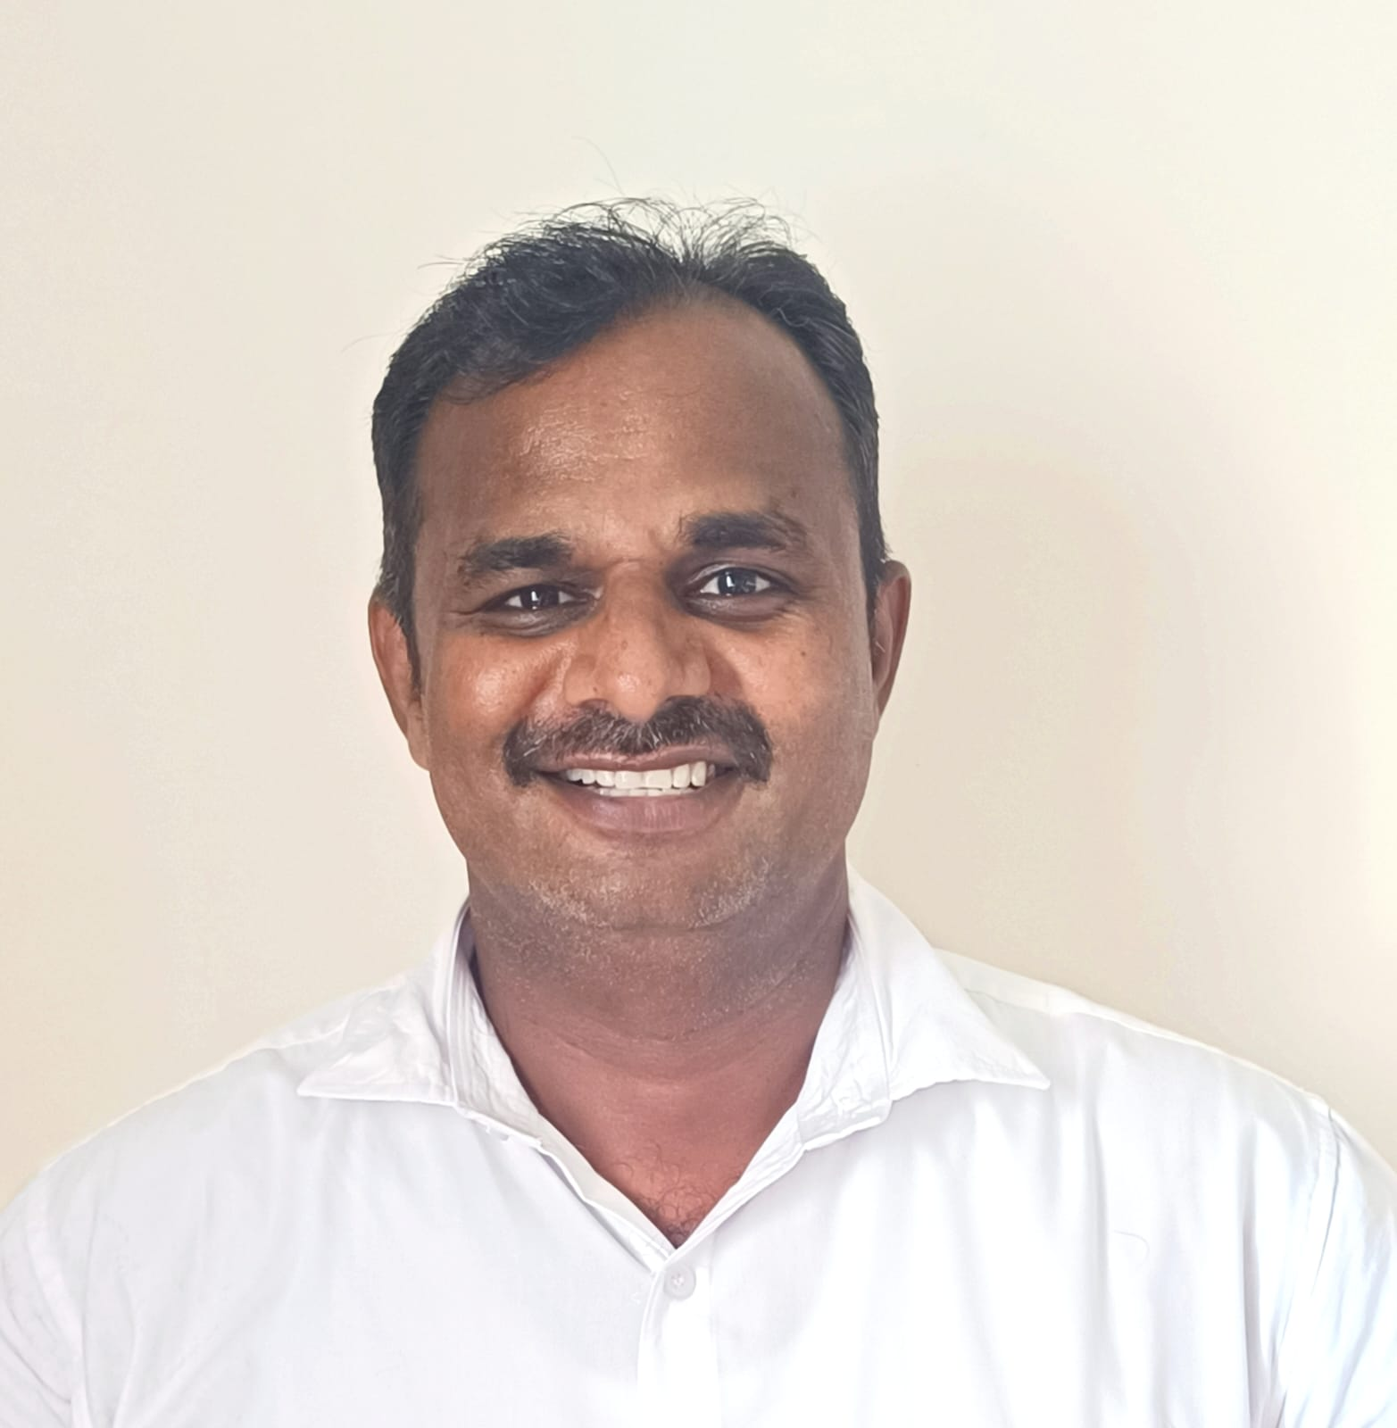
Designation: Nursing Tutor and Deputy Nursing Superintendent
Department: Nursing
Email id: dhanasekar@aiimsmangalagiri.edu.in
Educational qualification
Sl. No. | Degree | Year of passing | Subject | College/University
1 | BSC | 2006 | General Nursing and Midwifery | Sri Ramakrishna College Of Nursing
2 | Msc | 2011 | Pediatric Nursing | Sri Gokulam College Of Nursing
3 | PhD | Pursuing since 2024 | Pediatric Nursing | Pursuing In MAHER University

Research Profile:

Google Scholar:

Researchgate:

Any Other:

Area of interest: Quality Nursing

Membership of professional bodies:

Registered Nurse and Midwife

Lifetime membership in TNAI

Membership in Society of Cardiac Nurses

Honors and awards: Awarded as Best Nurse in International Nurses day organized by AIIMS,

New Delhi

Awarded as Best Nurse in Institution Forundation in AIIMS, Mangalagiri

Books/Chapters: Thirusangu S, Kavitha D, Dhanasekar VM, Rajakumaravelu R. Applied Biochemistry for B.Sc Nursing Students. 1st edition. Chennai: SAP Medical Publications; 2024.

Publications (Chronologically, Recent First ):

PUBLICATIONS

Prathiba PM, Shini D, Parveen A, Moin M, Dhanasekar VM, Prakasam P, Dsouza PR, Amutha VK, Mercy Mary TB. Respecting patient choice: a systematic review of patient autonomy and informed consent in nursing. Universe Int J Interdiscip Res. 2024 Oct;5(5):141-152. doi: 08.2020-25662434. ISSN (O) – 2582-6417. Available from: https://doi-ds.org/doilink/10.2024-93716578/UIJIR

Bharti R, Sharma S, Moin M, Dhanasekar VM, Ganguly R, Mishra A, Parthiban C, Chaturvedi D, Yadav M. Leveraging social media in nursing: strategies to boost patient engagement, education, and health promotion. Universe Int J Interdiscip Res. 2024 Oct;5(5):118-128. doi: 08.2020-25662434. ISSN (O) – 2582-6417. Available from: https://doi-ds.org/doilink/10.2024-93716578/UIJIR

Dhanasekar VM, Kumar L, Palanivelu P, Moin M, Thomas D, Chandran A, Chaturvedi D, Vijaya D, Shenbega Priya JS. Exploring the intersection of nursing and technology: a review of digital health tools. Universe Int J Interdiscip Res. 2024 Oct;5(5):106-117. doi: 08.2020-25662434. ISSN (O) – 2582-6417. Available from: https://doi-ds.org/doilink/10.2024-93716578/UIJIR

Dhanasekar VM. Building clinical judgment in nursing students: A progressive simulation approach. Universe Int J Interdiscip Res. 2025 Jul;6(2):24–34. doi:10.2020-25662434. Available from: https://doi-ds.org/doilink/07.2025-94835674/UIJIR

PATENTS

Elavarasi MS, Senthil T, Choudhary AS, Chauhan A, Sharma A, Chaturvedi C, Beulah D J, Dhanasekar VM, Lakshmi A, Deeksha. The Nurse's Nexus Bag (community Bag). Design No. 427775-001; 2024 Dec 18.

Bisht M, Rana VS, Moin M, Bhakare SS, Regina PF, Dhanasekar VM, Rajakumaravelu R, Bai TD, Thatcher GM, Bindhiya R. Smart hydration and nutrient tracking device. Design No. 435807-001; 2025 Jan 16.

Senthil, Kavin Mozhi J, Elavarasi R, Dhanasekar VM, Arti Mishra, Pappu B, Savithri KB, Vinnoli TS, Mythili K, Santhosh Priya N, Deepkant Chaturvedi. Smart Inhaler with Dosage Tracking Device. Application No: 202441062389 A; 23 Aug 2024.

Kankarwal M, Dhanasekar, Kumari K, Kumar S, Danasu, Kalyani CV. Medical Device-related Pressure Injuries: Knowledge, Practice, and Attitude of Nurses Toward Its Prevention in the Tertiary Care Center Across India. Nursing & Midwifery Research Journal. 2025:0974150X251384033.

