Curriculum Vitae

- Name: G. KALEESWARI
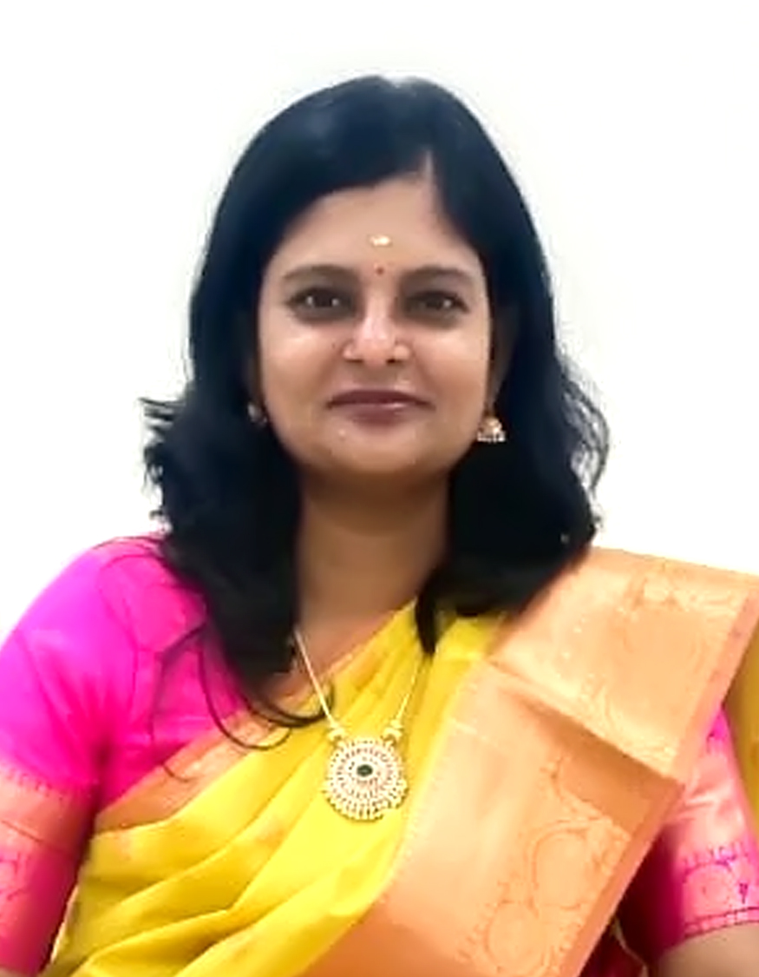
Designation: NURSING TUTOR/CLINICAL INSTRUCTOR
Department: Nursing
Email id: kalisaiims@aiimsmangalagiri.edu.in
Educational qualification
Sl. No. | Degree | Year of passing | Subject | College/University
1 | B.Sc Nursing | 2006 | - | The TamilNadu Dr.MGR Medical University, Chennai
2 | MSc Nursing | 2012 | Community Health Nursing | Sri Ramachandra University, Chennai
3 | PhD | scholar |  | BIHER, Chennai
4 | Any Other | PGD YOGA |  | TamilNadu Physical Education and Sports University, Chennai

Certificate of completion:
- Training course on Health System Management to strengthen Health care Delivery services from Ministry of Health and Family welfare, New Delhi.
- Gate keeper of suicidal prevention
- Good clinical practice
- Master diploma in counselling psychology
- Level I Simulation educator (Pedi Stars)
- Research methods in Health Promotion
- Advanced diet and Nutrition therapy
- Foundational and advance course on social and behavioural change communication by UNICEF
- BLS, ACLS, (American Heart Association), ATCN (Advanced Trauma Care Nurse) Provider
- TOT (Training of Trainers) as part of capacity building during COVID-19 epidemic, at AIIMS, Rishikesh
- Capacity building of Midwifery Faculty organised by INC & UNPFI

Research Profile:
Researchgate:https://www.researchgate.net/profile/Kaleeswari-Gunasekaran
Any Other:https://orcid.org/0000-0001-7736-2403

Area of interest:
- Prevention and Management of PCOS through complementary therapies
- Prevention of Adolescent anemia.
- Community –based antenatal care.
- Nurse led Community-Immunization clinics,campaigns,outreach activities against Childhood Vaccine preventable diseases.
- National Digital Health Mission
- Community -based Palliative care (Prevention, Early identification, home based holistic care).
- Complementary Therapy : Yoga
- Community emerging diseases

Membership of professional bodies:
- Nutritional Society of India
- SOCHINI: Vellore, Tamilnadu
- Trained Nurses Association of India
- Indian Red Cross society
- PCOS Society of India

Honors/Awards
- Best Yoga Teacher Award from TamilNadu Sports Yogasana Association
- Best Faculty Award
- Resource person in the CNE-Workshop on the theme ‘Ward Management’ funded by Ministry of Health & Family welfare
- Coordinator of 10th International Yoga Day in AIIMS, Mangalagiri
- Guest speaker in ‘4th Alumni Association-Expertise Networking Event’(Sri Ramchandra University)
- Resource person in various educational activities and academic counsellor for Bridge Programme Certificate in Community Health for Nurses (BPCCHN) (AIIMS, Rishikesh)
- Resource person in an Educational activity on “Programme updates and procedures: Control and prevention of non-communicable diseases (NCD)” ( AIIMS,Rishikesh)
- Trainer in VIA training program for staff nurses of Uttarakhand.
- Editorial Board Member in “International Journal of Oncological Nursing and Practices".
- Presented scientific paper in International conference and state level seminar.

Professional Summary:

Strengths include developing creative curricula, expert in conducting OSCE/OSLER, part of planning and executive team of first simulation based exam in community health nursing conducted at AIIMS, Rishikesh, during COVID-19 epidemic.

Presented scientific paper in International conference and state level seminar.

Publications :

1.G.Kaleeswari, Dr. S. Rajalakshmi , 2024, Nutritional Strategies In Polycystic Ovary syndrome: A Systematic Review.
South Eastern European Journal of Public Health. 10.70135/seejph.vi.2733

2.G.Kaleeswari, Dr. S. Rajalakshmi,2024.Prevalence, Awareness and Predisposing factors for Polycystic Ovarian Syndrome (PCOS) among young women in selected PHC. Available from https://kuey.net/index.php/kuey/article/view/4117

3. Conference proceedings: Effectiveness of planned teaching programme on awareness and attitude regarding early identification and management of polycystic ovarian syndrome among adolescent girls in selected hospital, 2023, ICAESM’2023 Conference ISBN No.978-93-5981-580

4. Neetu kataria, vasantha c kalyani, Sonia Gulia,Kaleeswari Gunasekaran, 2023. Knowledge Regarding Hypertension and Amount of Diet Consumption Among Adults FromUttarakhand: A Comparative Survey. Available from: https://www.researchgate.net/publication/370828251_Knowledge_Regarding_Hypertension_and_Amount_of_Diet_Consumption_Among_Adults_From_Uttarakhand_A_Comparative_Survey#fullTextFileContent

5 .G. Kaleeswari, C. Vasantha Kalyani, J.S. Jarani, Kusum K.Rohilla, 2021.Effect of yoga on pulse rate and blood pressure among women https://www.researchgate.net/publication/353681979_Effect_of_yoga_on_pulse_rate_and_blood_pressure_among_women/stats

6..Kaleeswari G. Effect of Ajwain oil inunction on joint for pain among elderly, 2019, 6(6) :49-60. Availablefrom:https://www.researchgate.net/publication/348870352_AJANR_-_Ajwain_oil_inunction_on_joint_for_pain_among_elderly

7.Conference proceedings: Assessment of nutritional status in a pregnant women cohort examining health effects of air pollution: Preliminary results from the SICAPHE study.September 2013. ISEE Conference Abstracts 2013(1):5200.DOI: 10.1289/isee.2013.P-3-15-04
8.Coneference proceedings: International Nurses Conference8th International Nurses Conference conducted at Sri Ramachandra University on Assessment of stressful life events and self efficacy among adolescents at selected schools in Thiruvallur district.

