Curriculum Vitae
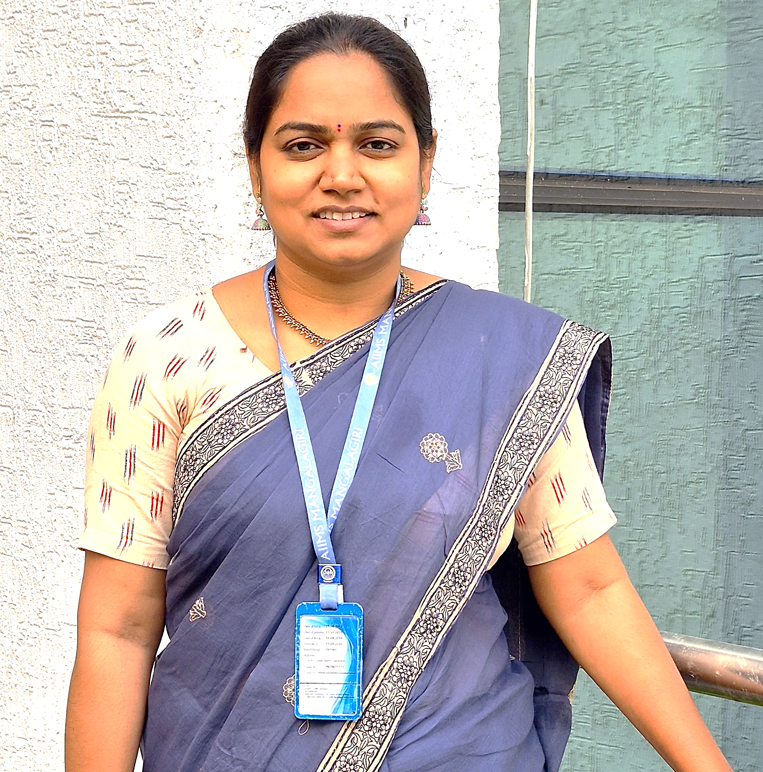

Name: Mrs Komakula NKS Santhoshi
Designation: Nursing Tutor / Clinical Instructor
Department: Medical Surgical Nursing – Cardio Thorasic Nursing
Email id: santhukomakula@aiimsmangalagiri.edu.in
Educational qualification
Sl. No. | Degree | Year of passing | Subject | College/University
1 | B Sc | 2010 | Nursing | Dr. NTR University of Health Sciences, Andhra Pradesh
2 | PGDCA | 2011 | Computers | Global Soft tech, Andhra Pradesh
3 | MA | 2014 | Sociology | Indira Gandhi National Open University (IGNOU)
4 | M Sc | 2017 | Med Surgical Nursing - CTVS | Dr. NTR University of Health Sciences, Andhra Pradesh
5 | Health Research Fundamentals | 2021 | Research | National Programme on Technology Enhanced Learning
6 | Ph D in Nursing | Pursuing | Med Surgical Nursing | National Consortium for Ph.D. in Nursing by Indian Nursing Council

Research Profile
- ORCiD - https://orcid.org/0009-0004-2761-2063

Area of interest:
- Cardio Thorasic Nursing
- Adult vaccination
- Nursing Informatics
- Mixed method Research
- Quality control

Membership of professional bodies:
- Life Member, Trained Nurses Association of India (TNAI)
- Life Member, Clinical Nursing Research Society (CNRS)
- Life Member, Society of Cardiac Nurses (SOCN)
- Life Member, Society of Midwives India (SOMI)
- Life Member, Society of Indian Hospice and Palliative Care Nurses Association (IHPCA)

Honors and awards:
- Second Position - Oral Presentation: International Conference on Translational and Technological Advances in Health Sciences (ICTAHS), Bangalore, 2025.
- Case Presenter - Cervical and Breast Cancer Prevention, Detection, and Awareness Capacity Building ECHO Program for Nursing Professionals in Chhattisgarh, organized by the College of Nursing, AIIMS Raipur in collaboration with ECHO India (2025).
- Master Trainer (Karmayogi) - Successfully completed the Capacity Building Commission 3-Day Karmayogi Facilitators Training Programme under the Rashtriya Karmayogi Large-Scale Jan Seva Programme 2025, Ministry of Health and Family Welfare.
- Poster presentation: Emerging Trends and Opportunities in Health care management, Acharya Nagarjuna University, 2024.
- Resource Person: Delivered Ward Management classes funded by the Ministry of Health and Family Welfare; contributed to World Cancer Day 2025 events and other institutional-level programmes.
- Certificate of Appreciation: Foundation Day 2021, AIIMS Mangalagiri.
- NCC - C Certificate: Naval Medical Unit, Andhra Pradesh.
Books/Chapters:
- Chapter Contributor: Assessment & Planning / Implementation in the Textbook of Educational Technology – Nursing Education for B.Sc. Nursing (Semester V), Vijayam Publications, ISBN: 978-93-95454-81-0, Edition 2025.
- Chapter Contributor: Nursing Management and Leadership, in Textbook of Nursing Management and Leadership for B.Sc. Nursing, Semester VI, Vijayams Publications, ISBN: 978-93-95454-73-5, Edition 2025.
- Special Contributor: Target High, 8th Edition, authored by Dr. Muthuvenkatachalam S. and Ambili M. Venugopal, CBS Publishers, 2025.
- Chapter Contributor: Introduction to Computer Applications in Nursing, in Textbook of Advanced Nursing Practice (as per the INC syllabus for M.Sc. Nursing Students), Iterative International Publisher (IIP), 2024.

Publications (Chronologically, Recent First):
- Conference proceedings: Cumulative Incidence, Contributing Factors, Knowledge and Attitude Towards Needle Stick Injury and Blood / Body Fluid Exposure Among Healthcare Workers in a Tertiary Care Hospital
- Komakula NKS Santhoshi, 2025, Transforming Healthcare Digitally: The Ayushman Bharat Digital Mission in a Tertiary Care Perspective. In Global Journal of Research in Medical Sciences (Vol. 5, Number 3, pp. 212–217). Gjr publication.
- The Role of Geographic Information Systems (GIS) In Public Health and Disease Surveillance. AJBR [Internet]. 2024 Dec. 31 [cited 2025 Sep. 15];27(4S):12004-9. Available from: https://africanjournalofbiomedicalresearch.com/index.php/AJBR/article/view/6075
- P. Avanthi Devi, Pusarla Prasanthi, Sandhya C, Komakula N.K.S. Santhoshi. Knowledge regarding prevention of Health Hazards of Junk Food among Adolescents (13-18). IJSR, ISSN: 2319-7064, SJIF (2022): 7.942.
- Arti Gupta, Rajeev Aravindakshan, Sathiyamoorthi Sathiyanarayanan, Navya Krishna Naidu, Komakula N.K.S. Santhoshi, Rakesh Kakkar. Validation of Gender Friendly Breastfeeding Knowledge scale among young adults. J Prev Med Hyg 2021; 62: E892-E903.

